
JIM JUNIOR SCHOOL - KIBUKU
“To Excel Is Our Aim”
Tel (+256)787643047 or (+256)756072716
Email: schooljimjunior@gmail.com

END OF TERM ONE EXAMINATIONS 2023
PRIMARY TWO
MATHEMATICS
DURATION: 2HRS 30 MIN
Name ____________________________________________________
 | Add correctly.  - 3 + 4 + 6 =  - 2 6  +1 3 |  | Draw these sets.  - A set of three trees.  - A set of two cows.
 | Count the beads and write the number.  - T O  - T O |  | Use a number line and add correctly.  - 5 + 1 = ………….  0  1  2  3  4  5  6  7  8  9  0  1  2  3  4  5  6  7  8  9  - 2 + 3 = ………….  0  1  2  3  4  5  6  7  8  9
 | Fill in the missing tens and ones.  - 84= ………tens ………..ones.  - 73= ………tens………..ones. |  | Circle the bigger number.  - 9 and 4  - 23 and 19
 | Name the shapes. |  | Match correctly.  Forty 100  Ninety five 31  Thirty one 40  One hundred 95
 | 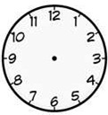  Tell the time.  It is ……………o’clock. |  | 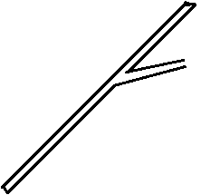  Use “longer” or “shorter”  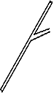  B  A  - Stick A is ………………..than stick B  - Stick B is ………………….than stick A
 | Add these sets.  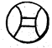  + =  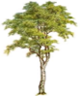  + = |  | Draw bundles of tens and ones.  - 14 =  - 21 =
 | Write the number before.  - ……………, 20  - ……………, 35 |  | Write in figures.  - Seventy …………………….  - Twenty six …………………
 | - Seven apples plus four apples equals  - Tom has 5 pens, Ashim has 9 pens. How many pens do they have altogether? |  | - How many legs do two girls have?  - A cow has ……………eyes.
 | Workout;  - Sh 5 0 0  + Sh 3 0 0  - Sh 6 0 0  - Sh 2 0 0 |  | - How many days make a week?  - Which day comes after Sunday?
 | Subtract correctly.  - 9 – 5 =  - 6 4  - 3 2 |  | - Write the shaded fraction.  =  - Shade $\frac{3}{5}$
 | Workout correctly.  - $\frac{5}{10} + \frac{2}{10}$ =  - $\frac{4}{7} - \frac{1}{7}$ = |  | Write in words.  - 27  ………………………………………….  - 11  ………………………………………….
 | Name the following shapes. |  | Fill in the missing numbers.  - 100, 101, …………………..  - 92, 93, ……………………..
 | Name the following shapes. |  | Use “an empty set” or “empty set”  - A set of cats with ten legs.  …………………………………..  - A set of boys with black shoes.  ……………………………………

END

